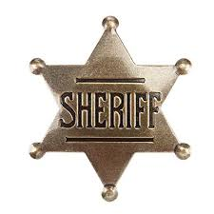 It’s Against the Law

Match the state to the law by putting the number from the left in the blank before the statement.
Even if your state isn’t in this list, don’t think it doesn’t have any whacky laws.

1. Alabama ____ It is illegal to lie down and fall asleep with your shoes on.
2. Arizona ____ It is illegal to share your Netflix password.
3. Florida ____ Slippers are not to be worn after 10:00 PM.
4. Georgia ____ A man may not knit during the fishing season.
5. Louisiana ____ Against the law to keep Christmas decorations up after January 14.
6. Maine ____ Go to jail if you keep an ice cream cone in your back pocket on Sundays.
7. New Jersey ____ Parking fees must be paid if you tie an elephant to a parking meter.
8. New York ____ A $500 fine for sending a pizza to someone’s house without their knowledge.
9. North Dakota ____ You’re breaking the law if you let your donkey sleep in a bathtub.
10. Tennessee ____ Illegal to wear a fake mustache that causes laughter in church.

Source: https://www.goodhousekeeping.com/life/travel/news/a36548/weirdest-laws-in-america/ accessed May 13, 2019.

