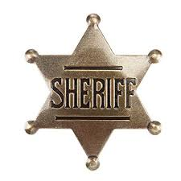 It’s Against the Law

Match the state to the law by putting the number from the left in the blank before the statement.
Even if your state isn’t in this list, don’t think it doesn’t have any whacky laws.

1. Alabama 9 It is illegal to lie down and fall asleep with your shoes on.
2. Arizona 10 It is illegal to share your Netflix password.
3. Florida 8 Slippers are not to be worn after 10:00 PM.
4. Georgia 7 A man may not knit during the fishing season.
5. Louisiana 6 Against the law to keep Christmas decorations up after January 14.
6. Maine 4 Go to jail if you keep an ice cream cone in your back pocket on Sundays.
7. New Jersey 3 Parking fees must be paid if you tie an elephant to a parking meter.
8. New York 5 A $500 fine for sending a pizza to someone’s house without their knowledge.
9. North Dakota 2 You’re breaking the law if you let your donkey sleep in a bathtub.
10. Tennessee 1 Illegal to wear a fake mustache that causes laughter in church.

Source: https://www.goodhousekeeping.com/life/travel/news/a36548/weirdest-laws-in-america/ accessed May 13, 2019.

