In My Family 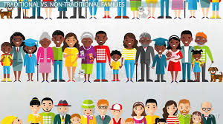

How does your family relate to the following things?
Are these clear or fuzzy, consistent or changing, fair or unfair?
What input do you have for the rules in your family?
Have any of the rules changed at any point in your life?
How do you think you will relate to these when you’re an adult, especially if there’s a child in your picture?

1. Meals ________________________________________________________________________________________
2. Bedtime _______________________________________________________________________________________
3. Household chores _______________________________________________________________________________
4. Homework _____________________________________________________________________________________
5. School ________________________________________________________________________________________
6. Church _______________________________________________________________________________________
7. Driving ________________________________________________________________________________________
8. Holidays ______________________________________________________________________________________
9. Vacation ______________________________________________________________________________________
10. Marriage ______________________________________________________________________________________

