Is your glass “Half Full” or “Half Empty”?

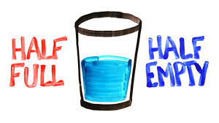

- Half Full
- Half Empty

There might be other options that match your perspective better. See if one of these more accurately expresses your outlook:

- If doesn’t matter if the glass if half empty or half full . . . be grateful that you have a glass.
- Be grateful there is something in the glass!
- People who wonder whether the glass is half empty or half full are missing the point: The glass is refillable.
- Empowered people don’t look at the glass as being half empty or half full because they are too busy filling it!
- If you see your glass as being half empty, pour it into a smaller glass.
- Why is the glass there in the first place? And why is there water all over the floor?
- It’s impossible for exactly half of a glass to be full.
- While you’re arguing about the glass of water, I drank it.
- You can’t look at a glass half full or half empty if it’s over flowing.

